1. spellman <- read.table('spellman.txt', header=T, row.names=1)
2. dim(spellman)

1. dd <- spellman[23:46, grepl("cdc15", colnames(spellman))]
2. dat.cor <- cor(dd,use = 'pairwise.complete.obs')

layout(matrix(c(1,1,1,1,1,1,1,1,2,2), 5, 2, byrow = TRUE))

par(oma=c(5,7,1,1))

cx <- rev(colorpanel(25,"yellow","black","blue"))

leg <- seq(min(dat.cor,na.rm=T),max(dat.cor,na.rm=T),length=10)

image(dat.cor,main="Correlation plot cdc15 samples 23 to 46",axes=F,col=cx)

axis(1,at=seq(0,1,length=ncol(dat.cor)),label=dimnames(dat.cor)[[2]],cex.axis=0.9,las=2)

axis(2,at=seq(0,1,length=ncol(dat.cor)),label=dimnames(dat.cor)[[2]],cex.axis=0.9,las=2)

image(as.matrix(leg),col=cx,axes=F)

tmp <- round(leg,2)

axis(1,at=seq(0,1,length=length(leg)),labels=tmp,cex.axis=1)

1. > k <- which(is.na(ds), arr.ind=TRUE)

> ds[k] <- rowMeans(ds, na.rm=TRUE)[k[,1]]

> ds.numeric <- as.numeric(ds)

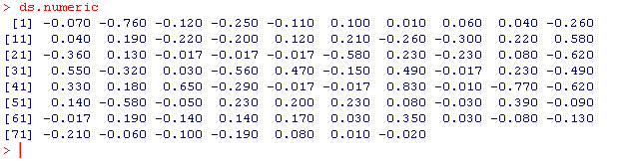

1. plot(1:77, ds.numeric,type='n',main="Profile plot of YAL002W",xlab="Samples",ylab="Expression",axes=F)

axis(side=1,at=c(1:77),labels=dimnames(ds)[[2]],cex.axis=0.4,las=2)

axis(side=2)

for(i in 1:length(ds.numeric)){

lines(1:77,ds.numeric, col=i,lwd=2)

}

a <- shinyServer(function(input, output){

selectedData <- reactive({de[,c(input$xcol, input$ycol)]})

colorScheme <- reactive({

if (input$colorBy == 'red'){

points(selectedData(),col='red', pch = 20, cex = 0.01, lwd = 1 )

}

else{

points(selectedData(),col='blue', pch = 20, cex = 0.01, lwd = 1 )

}

})

output$plot1 <- renderPlot({par(mar=c(5.1,4.1,0,1))

plot(selectedData(), pch=20,cex=1,lwd=1)

colour=colorScheme() })

})

ui <- shinyUI(pageWithSidebar(

headerPanel('cdc15'),

sidebarPanel(

selectInput('xcol', 'X Variable', dimnames(dd)[[2]]),

selectInput('ycol', 'Y Variable', dimnames(dd)[[2]],

selected=dimnames(dd)[[2]]),

selectInput('colorBy', 'Point Color', c('red', 'blue'))),

mainPanel(plotOutput('plot1'))

))